Unit: 3

Understanding By Design Template | 1
12.1: Minimizing Risk and Responding to Emergencies Resulting from Driver Error | 6
12.2: Preventing and Responding to Vehicle Failure Related Emergencies | 9
12.3: Practices and Procedures for Effectively Managing a Roadside Breakdown or Accident Scene. | 12
Supplemental Materials | 15

Chapter : 12 Emergency Response and Recovery

Stage 1 – Identify Desired Results
Established Goals
After completing this unit, students will…
- Demonstrate an understanding of strategies to minimize and respond to emergencies resulting from driver error.
- Understand and demonstrate the ability to appropriately assess and respond to a vehicle failure emergency
- Demonstrate an understanding of the practices and procedures required to safely and effectively manage a roadside breakdown or accident scene.

Essential Questions
- What are potential driver errors that could ultimately turn into an emergency response?  - How can weather conditions effect vehicle control and tire traction?  - What are the proper procedures to effectively respond to any emergency involving driver error or adverse weather conditions? | - Why is it important to understand the emergencies that may be caused by vehicle malfunction?  - What are the proper procedures to effectively respond to common vehicle malfunction emergencies?  - What current technologies are available that enhances our abilities to respond more effectively to vehicle emergencies? | - What are the necessary procedures for safely responding to a vehicle breakdown?  - What are the necessary procedures for properly managing and protecting an accident scene?  - What are your legal responsibilities when involved in an accident?
Desired Understandings
- There are a number of driver errors that could potentially result in an emergency response.  - Preparing for driving emergencies that can be caused by adverse weather conditions.  - There are many procedures which will aid in assessing and responding to a driver error or weather related emergency. | - Vehicles can break down at any time and can potentially cause an emergency response.  - The proper procedures to effectively respond to common vehicle malfunction emergencies.  - How to properly employ current technology systems intended to prevent, or help keep drivers safe, during a driving emergency. | - The proper steps to respond to a vehicle breakdown.  - The necessary procedures to properly manage and protect any accident scene.  - A driver’s legal responsibilities and requirements when involved in a vehicle accident.
Key Knowledge and Skills
Students will know…
- The potential driver errors that could trigger an emergency response.  - How adverse weather conditions may effect traction and other vehicle controls.  - The proper procedures to effectively respond to driver error and weather related emergencies. | - The common vehicle malfunctions that may result in a driving emergency.  - The procedures employed to effectively respond to vehicle malfunction emergencies.  - Current technologies that are available in many cars that help prevent or assist drivers more effectively in driving emergencies. | - The appropriate steps to employ to safely secure your vehicle when a breakdown or accident occurs.  - The proper procedures to effectively manage and protect an accident scene. (Stop, Warn, Notify)  - Their legal responsibilities and requirements when involved in a vehicle accident.
Students will be able to…
- Identify driver errors that could trigger an emergency response.  - Identify and assess various adverse weather conditions and how they impact tire traction and vehicle control.  - Discuss and demonstrate the vehicle control and emergency respond techniques employed when responding to an emergency involving driver error or adverse weather conditions. | - Identify all the common vehicle malfunction driving emergencies.  - Describe the proper procedures in responding to common vehicle malfunction driving emergencies.  - Recognize the modern technologies available in many cars that prevent or help assist drivers during vehicle emergencies. | - List and explain the importance of the steps necessary in safely responding to a vehicle breakdown.  - Identify all the procedures necessary to effectively manage and secure the accident scene.  - Explain their legal responsibilities when involved in a vehicle accident.
Audience
This unit is designed for high school driver education students, ages 16-18, who are enrolled in a Driver and Traffic Safety Training Course.

Stage 2 – Determine Acceptable Evidence
Goal 1 | Goal 2 | Goal 3
Performance Tasks
News Research Activity - Students will demonstrate an understanding of how driver error and adverse weather conditions have contributed to driving emergencies based on research they compile using news stories related to vehicle emergences.  Class Discussion – Students will demonstrate their ability to apply emergency response strategies through their contributions to a consensus listing of response strategies for the emergency conditions noted. | Internet Search  Student will research and document how technology can be designed and employed to assist in avoiding or responding to vehicle failure emergencies.  Class Discussion – Students will demonstrate their awareness of potential vehicle system failures and possible response strategies by contributing to the development of a class consensus listing.  Short Quiz - Students will demonstrate their knowledge of potential vehicle system failures and the most effective response strategies by successfully completing a written quiz on those topics. | Class discussion & Brainstorming  The students will identify common causes of vehicle breakdowns and brainstorm the appropriate steps to take when they occur.  Accident Scene Pre and Post Tests - Students will demonstrate their initial and resulting awareness and knowledge of a driver’s responsibilities in responding to an accident scene that involves an injury, fatality, or damage to property, by successfully completing a written pre and post test on those topics.
Other Evidence
BTW Activity –The student will demonstrate the ability to discuss and apply the emergency response concepts learned when presented with practice activities designed to simulate an emergency condition during an in-car driving session. | BTW Activity - Students will apply the skills and strategies learned by successful participation in the accompanying in-car driving session. | BTW Activity – The student will be able to successfully demonstrate the ability to perform a roadside tire change.
Student Self-Assessment and Reflection
Journal Activity  Students will reflect on, and write about, the techniques they have learned about in this lesson in relation to their own experiences or sample emergencies incidents. | Journal Activity  The students will reflect on the concepts presented and compile a list of best practices that might have been used to respond to a vehicle failure emergency scenario. | Sharing Personal Experiences  In this activity students will be given the opportunity to reflect on an accident or a vehicle breakdown they or a classmate, were involved in.

Stage 3 – Plan Learning Experience
 | Activity | W, H, E1, R, E2
Goal 1 | - News Research  - Class Discussion  - Power Point  - Supporting Video  - Self-Reflection and Journal Activity  - Supporting BTW Activity | W, H, E2  W, H E1, R, E2  W, E1  W, H,R, E1  W, H, E1  W, R, E2
Goal 2 | - Internet Search  - Class Discussion  - Presentation  - Short Quiz  - Self-Reflection and Journal Activity  - Supporting BTW Activity | W, H, E2  W, H E1, R, E2  W, H, E1  E2  W, R, E1  W, H, E1, R, E2
Goal 3 | - Class discussion & Brainstorming  - Accident Scene Pre-Test  - Classroom Sharing Activity  - Presentation & Class Discussion  - Law Enforcement Speaker  - Accident Scene Post Test  - Supporting BTW Activity | W,H,E1,R,E2  W,E1,E2  W, E1, R  W,H,E1,  W,H E1  E2  W,E1,E2
Technology/Resources
Internet Access, Ability to Project Slides/Videos, Black/White Board or Easel, Note Pads, Student Notebook, Student Journals

12.1 Minimizing Risk and Responding to Emergencies Resulting from Driver Error

Section Goal:

After completing this lesson the student will be able demonstrate an understanding of strategies to minimize and respond to emergencies resulting from driver error.

Essential Questions:
  - What are potential driver errors that could ultimately turn into an emergency response?
  - How can weather conditions effect vehicle control and tire traction?
  - What are the proper procedures to effectively respond to any emergency involving driver error or adverse weather conditions?

Desired Understandings:
  - There are a number of driver errors that could potentially result in an emergency response.
  - Preparing for driving emergencies that can be caused by adverse weather conditions.
  - There are many procedures which will aid in assessing and responding to a driver error or weather related emergency.

Key Knowledge and Skills:
Students will know…
  - The potential driver errors that could trigger an emergency response.
  - How adverse weather conditions may effect traction and other vehicle controls.
  - The proper procedures to effectively respond to driver error and weather related emergencies.
Students will be able to…
  - Identify driver errors that could trigger an emergency response.
  - Identify and assess various adverse weather conditions and how they impact tire traction and vehicle control.
  - Discuss and demonstrate the vehicle control and emergency respond techniques employed when responding to an emergency involving driver error or adverse weather conditions.

Learning Experience Outline (items in bold represent assessment activities):
- Newspaper Research W, H, E2
- Class Discussion W, H E1, R, E2
- Power Point W, E1
- Supporting Video W, H,R, E1
- Self-Reflection and Journal Activity W, H, E1
- Supporting BTW Activity W, R, E2

Chapter 12.1 Learning Experience Activities:

- Newspaper Research – (completed outside of class in preparation)
The objective of this assignment is to illustrate the frequency and causes of accidents that are related to driver error or poor decisions made while driving in adverse weather conditions.
- Materials/Resources/Technology:
- Blackboard, Whiteboard or easel, sample news articles (online or local paper), assignment sheet.
Instructions:
Prior to class have the students research a news story about a reported collision that was caused by driver error or adverse weather conditions from a newspaper or reliable online news source. Have the students bring the article to class and be ready to discuss the primary cause of the accident and the steps the driver might have taken to minimize the risk or impact of the collision.

- Class Discussion
The newspaper research, as well as, information related to the frequency of accidents will generate thought regarding how to prevent driver error related collisions.
- Materials/Resources/Technology
- Blackboard, Whiteboard or easel

Instructions: The instructor should facilitate a class discussion that focuses on the frequency and common causes of driver error and weather related accidents. Using the findings that students share from their research, generate a list of driver errors and common causes of vehicle emergencies. Supplement the student research, as needed, to ensure that the resulting list includes common driver error, as well as, weather and traction related emergencies. As the list is compiled, discuss each emergency and what potential actions can be taken to minimize the risk in each situation. Add the best response practices identified to the list for each of the emergencies. Provide and discuss current statistics related to the frequency of this type of accident.

3. Presentation & Class Discussion
Building on the vision and space concepts illustrated in the opening activity the Teacher will provide a brief presentation which explains and illustrates the key knowledge and skills targeted.
- Materials/Resources and Technology needed: a means to present digital slides and videos, Internet access, Slides and/or Videos focused on Visual Space and Following Distance (see sample resources)

Instructions: Provide a presentation detailing the specific causes, and recommended responses, for driver error and weather related crashes. The presentation should include the 3 controls drivers have control of, (acceleration, steering and braking), assessing the likelihood and responding to a loss of traction, types of collisions, minimizing the risk of a collision, use of evasive steering, and braking in an emergency, and other strategies and procedures employed to reduce risk and maintain control in an emergency situation. Have the students record the compiled list and frequency data from the class discussion, as well as, the response strategies information from the presentation in their notebooks.

Supporting Video
Having the students view videos that illustrate emergencies that can result from driver error and or adverse weather and highlighting strategies used to respond and reduce risk and impact will serve to reinforce the concepts and strategies included in the presentation.
- Materials/Resources/Technology
  - Internet Connection, Screen. Projector and/or DVD, VCR Player

Instructions: instructor will show a video(s) of the common driving emergencies. The video should include proper procedures for correctly responding to both weather related and driver error emergencies. (see sample resources for examples)

Self-Reflection and Journal Activity
Many new as well as experienced drivers have faced a driving emergency at some point in their life. Have the students begin to think about an emergency that they, a family member or a friend may have encountered.
- Materials/Resources/Technology
- Student journal, Pen
Instructions: Have the student’s record in their journals the emergency they have faced as either a witness or participant, and reflect on what corrective actions or preventative measures could have been taken to minimize the risk. Be ready to discuss with the rest of the class.

Supporting BTW Activity
It is important for all young drivers to understand the basic three controls they have over their car at all times (steering, braking, acceleration), and the effect they have on preventing or minimizing the risk of an emergency.
Instructions: During the behind the wheel session the instructor will review the three basic vehicle controls (steering, braking and acceleration) and their importance during a driver error related emergency. Evasive actions including steer right, steer left, brake and hold, and emergency acceleration should be reviewed, demonstrated, and practiced. This juncture also provides the opportunity to reinforce the car maintenance and fluid checks from previous lessons that play a key role in weather or traction related emergencies.

12.2 Preventing and Responding to Vehicle Failure Related Emergencies

Section Goal:

After completing this lesson the student will be able to understand and demonstrate the ability to appropriately assess and respond to a vehicle failure emergency

Essential Questions:
- Why is it important to understand the emergencies that may be caused by vehicle malfunction?
- What are the proper procedures to effectively respond to common vehicle malfunction emergencies?
- What current technologies are available that enhances our abilities to respond more effectively to vehicle emergencies?

Desired Understandings:
  - Vehicles can break down at any time and can potentially cause an emergency response.
  - The proper procedures to effectively respond to common vehicle malfunction emergencies.
  - How to properly employ current technology systems intended to prevent, or help keep drivers safe, during a driving emergency.

Key Knowledge and Skills:
Students will know…
  - The common vehicle malfunctions that may result in a driving emergency.
  - The procedures employed to effectively respond to vehicle malfunction emergencies.
  - Current technologies that are available in many cars that help prevent or assist drivers more effectively in driving emergencies.

Students will be able to…
- Identify all the common vehicle malfunction driving emergencies.
- Describe the proper procedures in responding to common vehicle malfunction driving emergencies.
- Recognize the modern technologies available in many cars that prevent or help assist drivers during vehicle emergencies.

Learning Experience Outline (items in bold represent assessment activities):
- Internet Search W, H, E2
- Class Discussion W, H E1, R, E2
- Presentation W, H, E1
- Short Quiz E2
- Self-Reflection and Journal Activity W, R, E1
- Supporting BTW Activity W, H, E1, R, E2

Chapter 12.2 Learning Experience Activities:

1. Internet Search
Prior to this class session, have students complete an internet search on a modern vehicle technology designed to assist drivers in avoiding or during a vehicle emergency as a homework assignment.
- Materials/Resources/Technology
- Computer with Internet Connection, Pen and Notebook
Instructions: Instruct the students to research different modern driving technologies designed to assist them in a driving emergency as part of a homework assignment. Have students record the name of the technology and a brief description on how it keeps drivers safe. Have students use their results in the class discussion prior to submitting it to be graded. (Note - the instructor may wish to provide an assignment sheet which suggests possible search sites and includes probing questions.)

2. Small Group Work
Begin the unit by having students brainstorm on response strategies for an assigned vehicle failure scenario.
- Materials/Resources/Technology
- Index Card detailing vehicle failure scenarios, Pad and Pen

Instructions: Instructor will have students divide up into small groups. A group leader will be identified and provided a card with the name of a vehicle malfunction driving emergency. The group will be tasked with compiling a list of steps to help minimize the risk of the emergency. This list will be used in the next exercise; class discussion.

3. Class Discussion
As the small groups report their findings to the class, students will reflect on the strategies and responses identified and compile a consensus list of appropriate emergency strategies and responses
- Materials/Resources/Technology
- Blackboard or Whiteboard, or easel

Instructions: Have the group leaders present their emergency to the class with the group’s list of procedures necessary to effectively respond. The instructor will engage the entire class in a discussion and or debate on the effectiveness of each group’s proposals. Once the group has come to consensus the teacher will list the steps for handling that emergency on the board.

4. Presentation and Class Discussion
Building on the emergency response strategies and concepts discussed in the opening activities, the Teacher will provide a brief presentation which explains and illustrates the key knowledge and skills targeted.
- Materials/Resources and Technology needed: a means to present digital slides and videos, Internet access, Slides and/or Videos focusing on driving strategies for responding to vehicle failure emergencies. (see sample resources), student notebooks

Instructions: The instructor will provide a presentation on vehicle malfunction emergencies. This presentation should include information on common vehicle malfunction emergencies and how to appropriately respond to them. Also included in this presentation will be list of all the modern technologies included in new cars designed to assist drivers in various emergencies. Students will record the key concepts from this presentation in their notebooks.

5. Short Quiz
Assess the knowledge and skills the students are taking from this lesson by having the students complete a short quiz focusing on the key concepts and skills conveyed.
- Materials: teacher constructed brief quiz. (See sample resources for an example)

Instructions: Administer a brief quiz on the causes and responses to common vehicle failure emergency concepts from this lesson. When you grade and return the quiz, review the correct responses and respond to any student questions or misunderstandings.

6. Journal Activity
Students will be asked to reflect on a vehicle malfunction emergency that they or a family member may have witnessed or actually been involved with. An alternative may be to have the instructor provide a sample incident.
- Materials/Resources/Technology
- Student journal and a pen

Instructions: Have the students write and reflect in their journal about a time when they or someone they knew were involved in a vehicle malfunction emergency. (An alternative may be to have the instructor provide a sample incident.) What steps were taken to minimize the risk? What could have been done to make the situation better?

7. Supporting BTW Activity
During the BTW driving session the instructor will explain the controls and systems that could break down and cause an emergency response.

Instructions: The instructor will explain to the students in BTW lab the systems and controls that could break down and cause an emergency. The instructors will also reinforce the actions taught to the students in the power point presentation. The lesson should also reinforce previous lessons concerning important fluid checks before driving (ie, power steering fluid, brake fluid, anti-freeze and oil). A brief lesson on stopping the car with the emergency brake at very low speeds (10 mph or less) may also be included in this lesson.

12.3 Practices and Procedures for Effectively Managing a Roadside Breakdown or Accident Scene.

Section Goal:
After successfully completing this lesson students will be able to demonstrate an understanding of the practices and procedures required to safely and effectively manage a roadside breakdown or accident scene.

Essential Questions:
- What are the necessary procedures for safely responding to a vehicle breakdown?
- What are the necessary procedures for properly managing and protecting an accident scene?
- What are your legal responsibilities when involved in an accident?

Desired Understandings:
- The proper steps to respond to a vehicle breakdown.
- The necessary procedures to properly manage and protect any accident scene.
- A driver’s legal responsibilities and requirements when involved in a vehicle accident.

Key Knowledge and Skills:
Students will know…
- The appropriate steps to employ to safely secure your vehicle when a breakdown or accident occurs.
- The proper procedures to effectively manage and protect an accident scene. (Stop, Warn, Notify)
- Their legal responsibilities and requirements when involved in a vehicle accident.
Students will be able to…
- List and explain the importance of the steps necessary in safely responding to a vehicle breakdown.
- Identify all the procedures necessary to effectively manage and secure the accident scene.
- Explain their legal responsibilities when involved in a vehicle accident.

Learning Experience Outline (items in bold represent Assessment Activities):
- Class discussion & Brainstorming W,H,E1,R,E2
- Accident Scene Pre-Test W,E1,E2
- Classroom Sharing Activity W, E1, R
- Presentation & Class Discussion W,H,E1,
- Law Enforcement Speaker W,H E1
- Short Quiz E2
- Supporting BTW Activity W,E1,E2

Chapter 12.3 Learning Experience Activities:

1. Class Discussion & Brainstorming – When a Breakdown Occurs
This activity will help to determine what the students know about the actions to take when a common vehicle breakdown occurs, including protecting and securing the scene.
- Materials/Resources/Technology
- Blackboard, White board, or Easel

Instructions: The Instructor will begin by asking the students to share the most common vehicle systems breakdowns. Compile a written list of the incidents offered by students and add any that they might have missed. Once a comprehensive list has been established, the teacher will facilitate a brainstorming discussion focused on the steps a driver should take to safely respond when a breakdown occurs, including protecting and securing the scene. The instructor will add these actions steps for each incident to the compiled list.

2. Accident Scene Pre-Test
Administer a brief pre-test focused on a driver’s responsibilities in responding to an accident scene that involves an injury, fatality, or damage to property.
- Materials/Resources/Technology
- Pre-test and a Pen

Instructions: Instructor will administer a short pre-test to see what the students know about handling different types of accidents. Include in this quiz questions regarding NY Law and reporting to the proper authorities. After collecting the completed pre-tests, review the questions with the students to gauge their prior learning regarding a driver’s responsibilities when an accident occurs.

3. Sharing Personal Experiences
In this activity students will be given the opportunity to reflect on an accident or a vehicle breakdown they were involved in.
- Materials/Resources/Technology
- Student volunteers

Instructions: In this activity, have student volunteers stand up and tell their own personal story about an accident or vehicle breakdown that they were involved in. Ask the student how it happened and what they did to manage the situation. Facilitate a discussion regarding what they could or should have done differently to better secure and protect the scene.

4. Presentation & Class Discussion
Building on the emergency response strategies and concepts discussed in the opening activities, the Teacher will provide a brief presentation which lists and explains the critical actions and responsibilities associated with a vehicle breakdown or accident.
- Materials/Resources and Technology needed: a means to present digital slides and videos, Internet access, Slides and/or Videos focusing on the actions and responsibilities associated with vehicle breakdowns and accidents (see sample resources), student notebooks

Instructions: The instructor will provide a presentation focusing on road side vehicle break downs and how to effectively manage and secure the scene. This presentation should include information on simple road side maintenance that can be performed, as well as, accident scene procedures, including NY State law regarding fatality, personal injury and property damage accidents, accident reports (MV-104), and critical information on how to secure and protect various types of accident scenes.

5. Law Enforcement Speaker
Including a presentation by a guest speaker from law enforcement will reinforce the importance and legality of the actions and responsibilities presented.
- Materials/Resources/Technology
- Guest Speaker will specify the materials and technology required for the presentation

Instructions: Instructor will introduce a guest speaker from law enforcement to discuss various topics concerning vehicle breakdowns, accident procedures and NYS law regarding fatality, personal injury and property damage accidents. A question and answer session will be provided at the end of the presentation.

6. Accident Scene Post Test
Assess the knowledge and skills the students are taking from this lesson by having the students complete a short quiz focusing on the key concepts and skills conveyed.
- Materials: teacher constructed brief quiz. (See sample resources for an example)

Instructions: Re-administer the pre-test given at the beginning of the class period; additional questions may be included, as needed to assess comprehension and retention of the material. When you grade and return the quiz, review the correct responses and clarify any student questions or misunderstandings.

7. Supporting BTW Activity
During the behind the wheel session students will become familiar with simple road side maintenance activities.
Instructions: The in-car session will focus on the critical steps to safely perform a tire change at the side of a roadway. The students will actually change a tire on the driver education vehicle. If time permits, or during another BTW session, students will learn all the critical steps involved with jump starting a car. This is also a good time to view the vehicle emergency kit inside the driver education vehicle and discuss what goes into a road side emergency kit.

Supplemental Materials Appendices:

The following are samples of resource materials that may be used to supplement the instructional activities in this chapter. Here is where we really need your help and input! Please share the materials (Slides, Videos, Web links, Activities, Quizzes, Journal Templates, etc.) that you have found effective. Email them to us ASAP so we can include them with the final Chapters. Please take a moment to include a brief description of how you use the resource and student response and learning you have witnessed when you use them. THANK YOU for helping us to make this document the best resource for the Driver Education Teachers and Students in our State

Lesson 12.1 Newspaper Research
Lesson 12.1 List and Discuss
Lesson 12.1 Self-Reflection and Journal Activity
Lesson 12.1 Power Point
Lesson 12.1 Video
Lesson 12.1 Supporting BTW Activity
Lesson 12.2 Small Group Work
Lesson 12.2 Class Discussion
Lesson 12.2 Journal Activity
Lesson 12.2 Internet search
Lesson 12.2 Power Point
Lesson 12.2 Video
Lesson 12.2 Short Quiz
Lesson 12.2 Supporting BTW Activity
Lesson 12.3 Vehicle Breakdown Strategies
Lesson 12.3 Accident Scene Pre-Test
Lesson 12.3 Classroom Sharing Activity
Lesson 12.3 Power Point
Lesson 12.3 Law enforcement Speaker
Lesson 12.3 Supporting BTW Activity

Lesson 12.1 Newspaper Research

Name:________________________________________ Date___________

Instructions: Student will be asked to search through any newspaper to find an article where a collision was caused by driver error in normal or adverse weather conditions. Student should bring the article to class and be ready to answer the following questions:

What was the primary cause of the accident?

What steps could have been taken to prevent the accident?

What steps could have been taken to reduce or minimize the severity of the accident?

Lesson 12.1 List and Discuss

Instructions: As part of a classroom discussion students will be asked to compile a master list of driver error related emergencies. The list should include weather related and/or traction related emergencies. Once the teacher has compiled a master list on the board, go through each emergency, and discuss what potential actions could be taken to minimize the risk of each situation. Compile a master list of the best practices for each the emergencies.

Driver Error/Weather Related Emergencies Actions

Emergency Best Practice

1.

2.

3.

4.

5.

6.

7.

8.

Lesson 12.1 Self Reflection and Journal Activity

Name_________________________________________ Date___________

Instructions: Student will record in their journals an emergency that they may have faced as either a witness or as participant. Next they should reflect on what corrective actions or preventative measures could have been taken to minimize the risk of the emergency. Record these self-reflections in your journal. Be ready to discuss them with the rest of the class.

Emergency Faced

Type of Emergency

Preventative or Corrective Measures

Lesson 12.1 Power Point

Instructions: Students will view a power point presentation that includes all the common driver error and weather related emergencies that they could potentially encounter while driving a motor vehicle. The presentation will also include procedures on how to properly prevent or minimize the risk of each emergency.

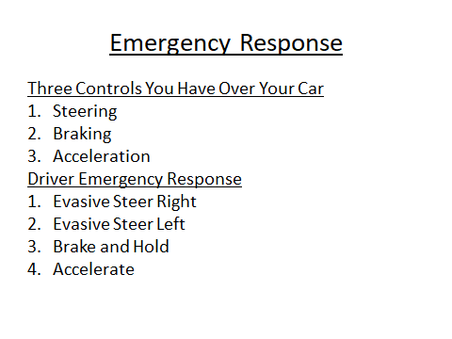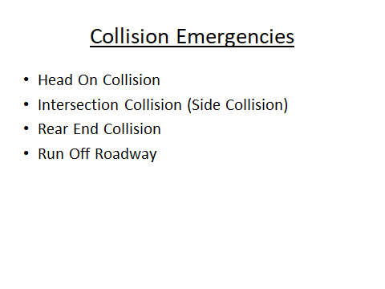
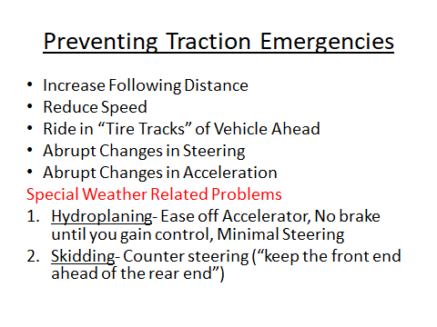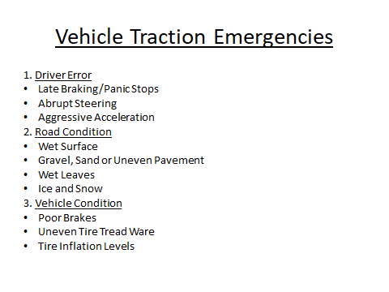

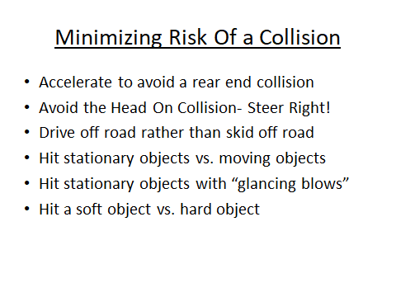

Lesson 12.1 Video

Instructions: Students will watch a video(s) on Driver Error, Weather and or Traction Emergencies.

Driving in Bad Weather AAA- You Tube
https://www.youtube.com/watch?v=nZ4w7enWbos

How to Control a Skid- You Tube
https://www.youtube.com/watch?v=YEAt27Rzb54

Controlling a Skid- Consumer Reports- You Tube
https://www.youtube.com/watch?v=EXEh_-a-p9o

What to do if you Hydroplane-You Tube
https://www.youtube.com/watch?v=TdwuftIUwYY

Driving Emergency-Run off Road AAA-You Tube
https://www.youtube.com/watch?v=KevWgHWtvXk

Understanding Car Crashes IIHS- You Tube
https://www.youtube.com/watch?v=yUpiV2I_IRI

Lesson 12.1 Supporting BTW Activity

Instructions: It is important for all young drivers to understand the basic three controls they have over their car at all times (steering, braking, and acceleration) , and the effect each of these has on preventing or minimizing the risk of an emergency. The evasive actions of steer right, steer left, brake and hold, and emergency acceleration should be reinforced. This may also be a good time to reinforce the important car maintenance tips and fluid checks that become extremely valuable in a weather or traction related emergency.

Notes:

Lesson 12.2 Small Group Work

Instructions: Instructor will have students divide up into small groups. A group leader will be identified and handed a card with the name of a vehicle malfunction driving emergency. The group will be tasked with compiling a list of steps to help minimize the risk of the emergency. This list will be used in the next exercise; class discussion.

Vehicle Malfunction Emergencies:

Tire Blowout/ Loss of Wheel

Stuck Accelerator

Loss of Brakes

Steering Failure

Engine Overheating

Hood Flies Up

Loss of Headlights

Lesson 12.2 Class Discussion

Instructions: Group leaders will present the emergency they were assigned to the class with a list of procedures necessary to handle each one. The instructor will engage the entire class in a group discussion and or debate on the effectiveness of each group’s proposals. Once the group has come to a consensus, the teacher will list the steps for handling that emergency on the board.

Notes:

Lesson 12.2 Journal Activity

Name__________________________________________ Date______________

Instructions: Students will write and reflect in their journal about a time when they or someone they knew were involved in a vehicle malfunction emergency. What steps were taken to minimize the risk? What could have been done to make the situation better?

What was the emergency?

What steps were taken to minimize the risk?

What steps could have been taken to make the situation better?

Lesson 12.2 Internet Search

Name_________________________________________ Date___________

Instructions: As part of a homework assignment students will research different modern driving technologies designed to assist them in a driving emergency. The name of the technology should be recorded as well as a brief description on how it keeps the driver safe. Remind them to bring their results to class for a discussion.

Notes:

Lesson 12.2 Power Point

Instructions: Students will watch and take notes on a power point presentation relating to vehicle malfunction emergencies. Included in this presentation will be information on common malfunction emergencies and how to appropriately handle each one. Also included in this presentation will be list of all the modern technologies included in new cars designed to assist drivers in various common emergencies.

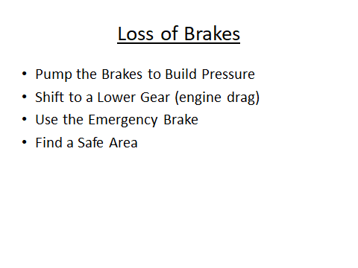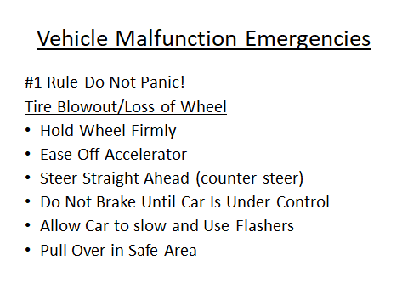

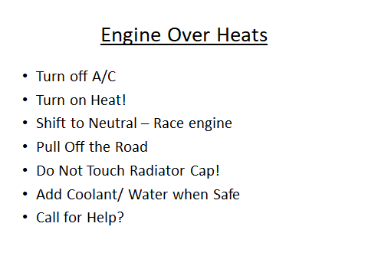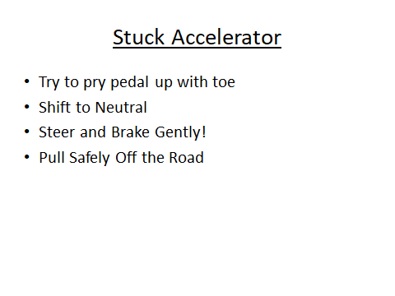
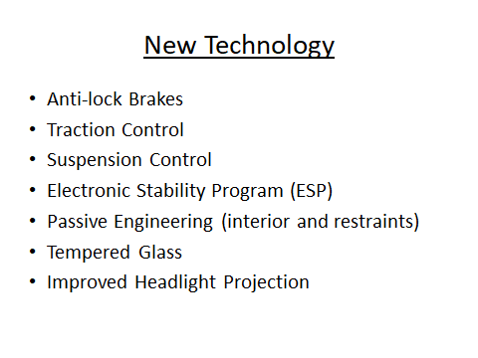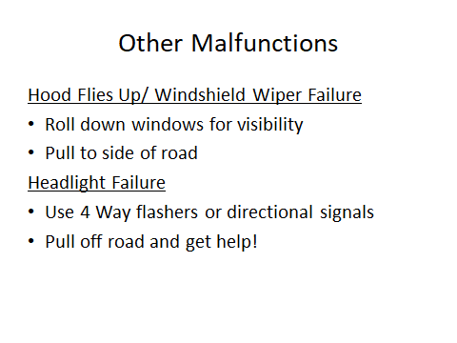

Lesson 12.2 Video

Instructions: Students will watch a video(s) dealing with vehicle malfunctions and new car technology.

Stuck Accelerator-AAA You Tube

https://www.youtube.com/watch?v=80CwVVuN4_c

Tire Blowout-AAA- You Tube

https://www.youtube.com/watch?v=9LHmeuzhH4o

How to Change a Flat Tire-AAA YouTube

https://www.youtube.com/watch?v=ZlkzohXBxWE

Unlocking the Mystery of Anti-lock Brakes-AAA You Tube

https://www.youtube.com/watch?v=fEudqGL5n2Y

Stability Control- How Does ESP Work- Bosch- You Tube

https://www.youtube.com/watch?v=Y2uXzp2HzKg

Lesson 12.2 Short Quiz

Instructions: Teacher will hand out a short quiz to test the students’ knowledge of vehicle malfunction emergencies and how to properly handle them.

Name___________________________________ Date______________

List the procedures for each vehicle malfunction:

Tire Blowout

_______________________________________

_______________________________________

________________________________________

________________________________________

________________________________________

_________________________________________

Engine Overheats

_________________________________________

__________________________________________

__________________________________________

___________________________________

____________________________________

____________________________________

Brake Failure

______________________________________

______________________________________

______________________________________

______________________________________

Stuck Accelerator

______________________________________

_______________________________________

_______________________________________

_______________________________________

Lesson 12.2 Suggested BTW Activity

Instructions: The instructor will explain to the students in BTW lab the various systems and controls in a car that could break down, and result in an emergency. The instructor will also reinforce the corrective actions previously taught during the power point presentation. The lesson should also reinforce previous trainings concerning pre-driving fluid checks (ie, power steering fluid, brake fluid, anti-freeze and oil). A brief lesson on stopping the car with the emergency brake at very low speeds (10 mph or less) could also be employed in this lesson.

Lesson 12.3 Vehicle Breakdown Strategies

Instructions: Instructor will quiz the students on the most common vehicle systems/controls in their car that might fail and cause a breakdown on the road. Compile a list of these student suggestions on the blackboard. Once they have compiled this list, quiz them on what steps they would take to handle each situation. Ask them how they would protect and secure the breakdown scene. Review the list and add a list of the best suggestions.

What vehicle systems and controls can breakdown?

What can be done to prevent or minimize each situation?

How would you secure and protect the breakdown scene?

Lesson 12.3 Accident Scene Pre-test

Instructions: Instructor will administer a short pre-test to see what the students know about handling different types of accidents and appropriate NY Law.

Name_____________________________________ Date_____________

True or False

It is a criminal violation to leave the scene of a personal injury accident. True

It is a criminal violation to leave the scene of a fatality accident. True

You do not have to stop if collision only involves minor damage to property. False , information must be exchanged (motorist ID #, registration and insurance)

A dog does not count as personal property. False

A cat does not count as personal property. True

If someone is injured or killed the police must be notified. True

If personal property damage is over $1000 you have to notify the police. True

Give 3 steps you could take to protect an accident scene:

__________________________9. _______________________ 10._________________________
(stop close to scene and get off road, warn other drivers with cones or flares, notify law enforcement)
(NYS Driver’s Manual)

Lesson 12.3 Classroom Sharing Activity

Instructions: In this reflection have student volunteers stand up and tell their own personal story about an accident or vehicle breakdown that they were involved in. Ask the student how it happened and what they did to manage the situation. Quiz them on what they could or should have done differently to secure and protect the scene.

What happened?

How did you manage the situation?

What could you have done differently?

Lesson 12.3 Power Point

Instructions: Students will view a power point presentation that covers road side vehicle breakdowns, and how to effectively manage and secure the breakdown scene. The power point will also include simple road side maintenance that can performed.. Accident scene procedures will include information on NY State law regarding fatality, personal injury and property damage accidents as well as information about accident.
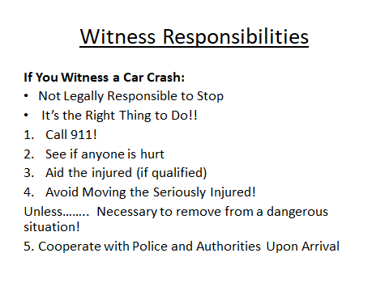

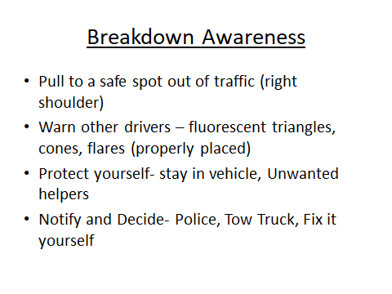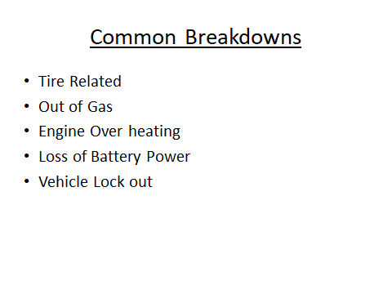

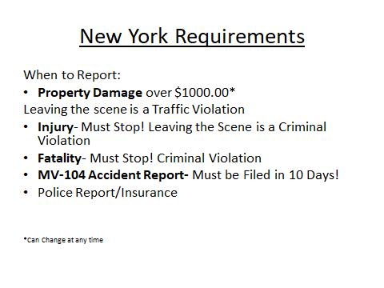
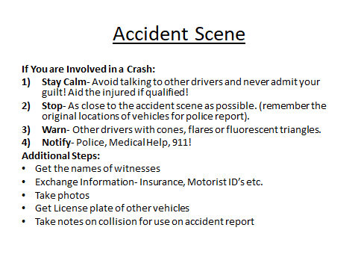

Lesson 12.3 Law Enforcement Speaker

Instructions: Instructor will introduce a guest speaker from law enforcement to discuss various topics concerning vehicle breakdowns, accident procedures and NYS law regarding fatality, personal injury and property damage accidents. A question and answer session will be provided at the end of the presentation.

Notes:

Lesson 12.3 Supporting BTW Activity

Instructions: During their normal behind the wheel session students will learn all the critical steps on how to safely perform a tire change. The students will physically perform change a tire on the driver education vehicle. If time permits or during another BTW session students will also learn all the critical steps involved with jump starting a car. This is also a good time to view the vehicle emergency kit inside the driver education vehicle and discuss what goes into a road side emergency kit. This is also a great time to discuss the importance of safely performing simple vehicle maintenance at a breakdown scene.

W,H,E1,R,E2 – an acronym for considering and self-assessing the key elements and logic of a learning plan. W: Where – ensuring that the student sees the big picture, has answers to the “why?” questions, knows the final performance expectations H: Hook – immersing the student immediately in the ideas and issues of the unit, engaging the student E1: Equip and Experience – providing the student with tools, resources, skills and information needed to achieve the desired understandings and accomplish the performance tasks R: Rethink – enhance understanding by shifting perspective, considering different theories, challenging prior assumptions, introducing new evidence, providing the opportunity to revise/polish prior work E2: Evaluate – ensuring that students get diagnostic and formative feedback and opportunities to self-assess and self-adjust

